BRAND | PHOTO | DESCRIPTION | COLOUR | 1 | 2 | 3 | 4 | TOTAL PIECES | PRICE
GOLDEN LADY SUMMER 2023 COLLECTION | 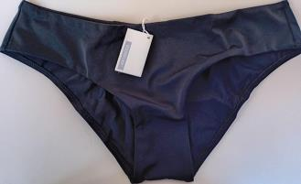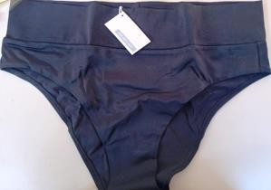 | LOWER PART SLIP OR CULOTTE | BLACK | 173 | 901 | 37 | 124 | 1.235 | 2,50 €
GOLDEN LADY SUMMER 2023 COLLECTION | 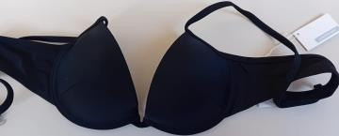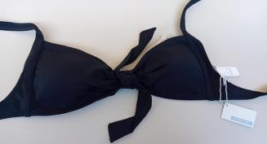 | UPPER PART BRA IN TWO MODELS | BLACK | 265 | 1166 | 600 | 0 | 2.031 | 2,50 €
 |  |  |  |  |  | TOTAL |  | 3.266

